CENTRAL HIGH SCHOOL KASANJE
S1 END OF YEAR EXAMINATION
TIME: 1½ HOURS
INSTRUCTIONS: Attempt all questions.
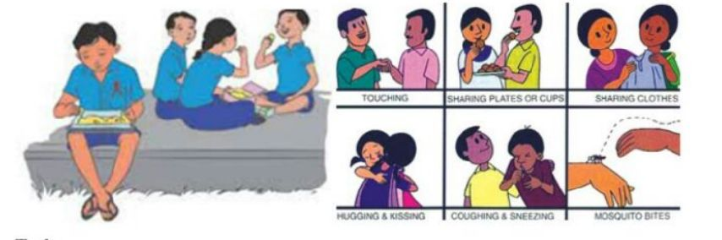
1. Opat a senior one student from oloba village has been battling with fear and enigma. His father, a 50 year old man has been diagnosed at the local health center in the village and found HIV positive. The rumuor about his father's HIV status has been spreading the entire village and people are afraid of of associating with any member of Opat's family. Students at school also don't want associate with him. The issue has reached administration and the administration has decided to invite the health personnel from the village health center to talk to students about the problem in the school.

Task.
As a health personnel write a speech you would deliver to the students gathered on the school assembly.

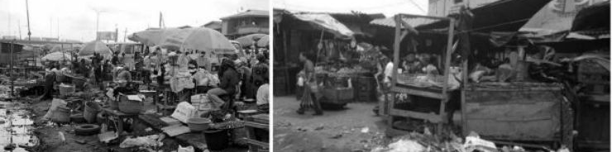
2. In Maswanku village at the shores of L. Victoria, there is a village market located near the swamp. In this busy market, there are lots of rubbish heaps scattered amongst congested stalls. One of the major merchandise sold is honey and some locals in the area make bricks just near the market in the swamp. A clinical officer in the area has reported high cases of patients suffering from diseases like cholera, malaria and diarrhea. The district health officer (DHO) has organised a sensitization campaign in the area about the situation.

Task:
As a health officer in the area, write a speech you would deliver to the locals tn the area to address the problem.

3. Your community intends to open an animal sanctuary composed of only chordates. This is hoped to protect the animal and be used both as an educational and tourism facility. The sanctuary will have 5 sections to the main five groups of chordates.

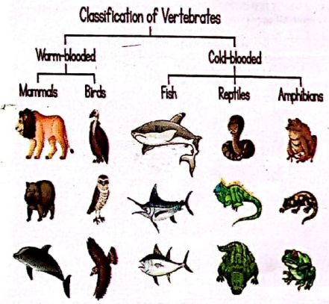

Task: As the first manager, write brief notes about chordates that you will have attached to each section of the sanctuary.

Merry Christmas and Happy New year END

